Training Guide for Sales and Customer Support

Background
Background information:

According to the CDC, approximately 90% of American healthcare spending is for chronic conditions such as diabetes, heart disease, and obesity. If we extrapolate this to Kaiser Permanente’s annual operating costs, we estimate that we spend over $13.6 billion per year on chronic diseases. However, many of these conditions are preventable. As a result, other healthcare companies, such as Cigna and Optima Health, are turning to the use of digital therapeutics to help control costs. For this reason, Kaiser Permanente management has expressed a desire to expand our offerings in the preventative care space.

Problem:

Kaiser Permanente has long been recognized as a leader in preventative care. Over the years we have developed a number of resources and toolkits, however these are currently scattered across various locations and platforms and cannot be accessed by all 12.2 million of our members. We could choose an off-the-shelf digital therapeutic solution such as Omada, but it focuses on managing already existing chronic conditions, not necessarily on preventing their occurrence in the first place.

As an integrated managed care provider, we have access to both patient care data, as well as insurance cost data. This presents a real opportunity for us to distinguish ourselves from our competitors. We propose to integrate all of our tools and experience into a new mobile app, focusing on both prevention and chronic disease management. Assuming we see a success rate similar to the competition, we estimate cost savings of over $1.1 billion.

Product Goals:
- Provide the user with functions to help prevent chronic disease, as well as to manage any existing conditions
- Increase overall member health and satisfaction
- Use data acquired through the app to improve the patient’s care

Market background
Market information specific to Sales:

In the sections below we define market information specific for our app. However, as we will initially be launching the app at no cost, this information may be less relevant to the Sales team as they are not selling the product per se. We are interested, however, in pursing relationships with advertisers, including for sponsored content within the app. Therefore, we will provide information in this section regarding our target audience and market specific to Sales for selling product advertising.

What are we selling:
- Small banner ads within the app
- Sponsored content (news articles or tips about how to better use the advertiser’s product)
- Challenges – Offering coupons and/or discounts to those who complete a health challenge in the app (i.e. run 30 minutes a day for 30 days straight, etc.)

Target Audience – Ad Sales:

Kaiser Permanente already has a number of relationships with product vendors and service providers that offer discounts to our customers. We would like to target these companies first and see if they could sponsor one or more challenges or if they would be interested in banner advertising or sponsored content.

Additionally, we should target companies who provide products and services to people who are concerned with preventative health and/or managing chronic conditions. For example:
- Fitness centers
- Home gym/exercise equipment vendors
- Fitness clothing makers
- Medical device manufacturers (smart scales, glucose readers, etc.)

Target Market – Sales:

Our application will be rolled out gradually to all 12.2 million Kaiser Permanente members. When targeting potential advertisers, it will be helpful if they understand that they will be targeting people who are already interested in improving their health and who may be much more likely to buy their product than a general audience.

Target market - App:

Our target market includes adult Americans between the ages of 18 up to 65 who could potentially choose Kaiser Permanente as their healthcare provider. This includes approximately 193 million people. (Source: https://www.statista.com/statistics/241488/population-of-the-us-by-sex-and-age/)

Target audience - App:

Our target audience includes all Kaiser Permanente members (customers), of which there are currently approximately 12.2 million. However, within this audience, we are particularly interested in attracting users who are already suffering from a chronic condition such as obesity, diabetes or cardio-vascular disease, or are currently at risk for developing one. Helping these members control their disease through daily monitoring and use of the app will help us realize our goals of increased customer health and happiness, as well as decreased spending for chronic conditions.

Competitors:

There are two apps that stand out in doing both weight management (activity and nutrition logging), as well as chronic disease management: Omada and Livongo. We will make the assumption that these are the two best candidates with which to compare our proposed app.

Omada is digital therapeutics company with an estimated annual revenue of $104 million. (Source: https://www.owler.com/company/omadahealth). As of 2018 they had approximately 85,000 users (Source : https://www.fastcompany.com/company/omada-health). It should be noted that Kaiser Permanente is an investor. Omada focuses particularly on diabetes, hypertension and behavioral health management. Additionally, they offer coaching and social networking features inside the app. Users are also provided with a smart scale to be used with the app. Their customers include Cigna, Blue Cross Blue Shield, Optima Health, and some Kaiser Permanente locations.

Livongo is another digital therapeutics company that has been rapidly growing. Their estimated annual revenue is $290 million and they claim to have 207,000 members (Source: https://www.owler.com/company/livongo). They recently purchased the myStrength behavioral health app that Kaiser Permanente uses. Livongo focuses mainly on diabetes, hypertension, behavioral health and weight management. They offer coaching and prescription refills within the app. In addition to a smart scale, they provide users with glucose readers and blood pressure monitors. Their customers include Mount Sinai Group, Mission Health, and Blue Cross Blue Shield. Additionally, Medicaid and Medicare customers are eligible.

Product Background
Key Features of the product:

Feature | Description
User Accounts | Users can create accounts based on their member id and other person information.  Users can log in to the account they created. They should also be able to change their password if necessary.
Meal Logging | Users should be able to add, modify and delete food items and nutrition (calorie) information for meals. Meal categories include breakfast, lunch, dinner and snacks.  The user should be able to view the information that they’ve entered in (via the daily log) and see a running tally of the total calories they have consumed that day.  Users should be able to search for food items to add via a large database that contains calorie/nutrition information.
Activity Logging | Users should be able to add, modify and delete exercise activity. Calories burned should be calculated automatically based on the activity type, user’s weight and minutes exercised.  If the user has not yet entered in their weight, they should be prompted to do so.  The user should be able to view the information that they’ve entered in (via the daily log) and see a running tally of the total minutes exercised and calories burned for that day.  Users should be able to search for activity types to add via database that contains activity information. If the user does not find their activity type they should be able to manually add the activity and calories burned.
Daily Log | The user should see a summary of the data that they’ve entered into the app for the given day. This should include:  - Meals  - Physical activity  - Other health data (See the health data section below.)  The user should be able to see the total calories consumed by meal, as well as an overall total. They should also be able to see the total amount of calories that they’ve burned.

Known Issues:

At this time the product has no known issues. Please note that the initial launch will include weight management and meal and activity logging. Auto logging via trackers and fitness challenges are scheduled for subsequent follow-up releases in the short term.

Screenshots:

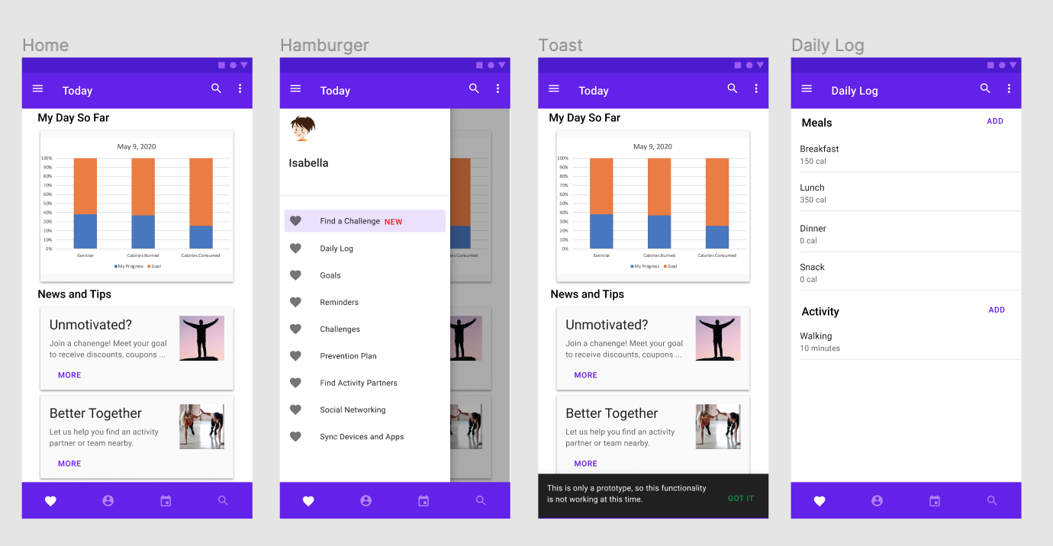

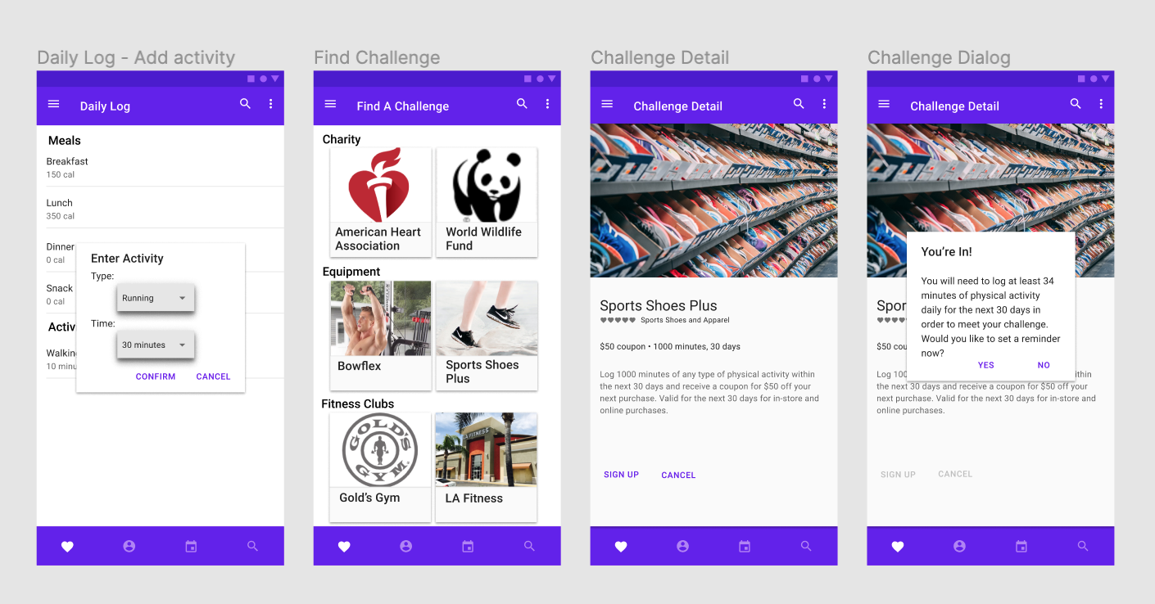

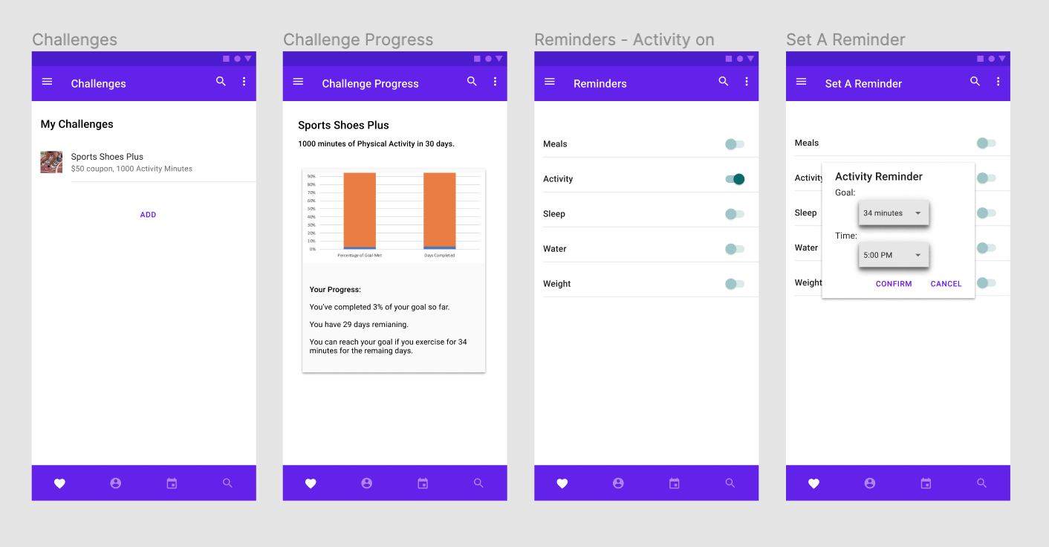

Pricing:
As mentioned above, the app will initially be launched at no cost to users, but will include banner ads and sponsored content. Therefore, we do not have pricing packages or discounts/offerings to speak of in terms of the app itself. However, we can offer the following guidelines as you negotiate with potential advertisers:
- Pricing for banner ads and sponsored content should be in-line with what we charge in any of our other products (website, etc.)
- Pricing for banner ads and sponsored content should also be competitive with what competitor apps charge (i.e. Omada, Livongo, MyFitnessPal, etc.)
- As we are just launching the product, we can offer discounts to advertisers who commit to us early on (for example., 15-20% off market rates for those who sign up in the first two months of our initial launch).

Benefits to users and consumers:
- A one-stop-shop for information about preventative health, making easy to be one’s healthiest
- Customized preventative health plan to help users prevent chronic disease or manage an existing condition
- Easy communication between patients and chronic care managers about health issues and progress

How to use the product:
After opening the app on your mobile phone, you will be prompted for your member id and password, if you are not already logged into the app. You will also have the option to create a new account if you have not yet done so.

After a successful login, the Today screen appears and shows the amount of progress you’ve made towards your goals for minutes exercised, calories-burned and calories consumed (what you’ve eaten). Below that you will see a list of helpful tips and news.

You can navigate through the product via the hamburger menu on the left-hand side of the screen. Simply click the three bars on the top left-hand side of the screen to open the menu.

Please see the “User Guide” document for further detailed information.

Where users can find the product:
Users will be able to download the product from either the Apple App Store (iPhone or iPad) or from the Google Play Store (Android devices). Links to both of these will also be provided on Kaiser Permanente’s website, in its ‘Health & Wellness’ section.

